How to Use AIRM

Overview:
This document describes how to install AiRM Application Software on your computer
System Requirements:
- Operating Systems Compatible:
  - Windows 11 (32bit/64bit),
  - macOS Tahoe version 26
Directions:
- To begin the installation of AiRM, make sure you are using Google Chrome Version 142.0.7444.60
- In the web browser in the search link, navigate to https://github.com/AiRM-ai/app. The page should look like this:
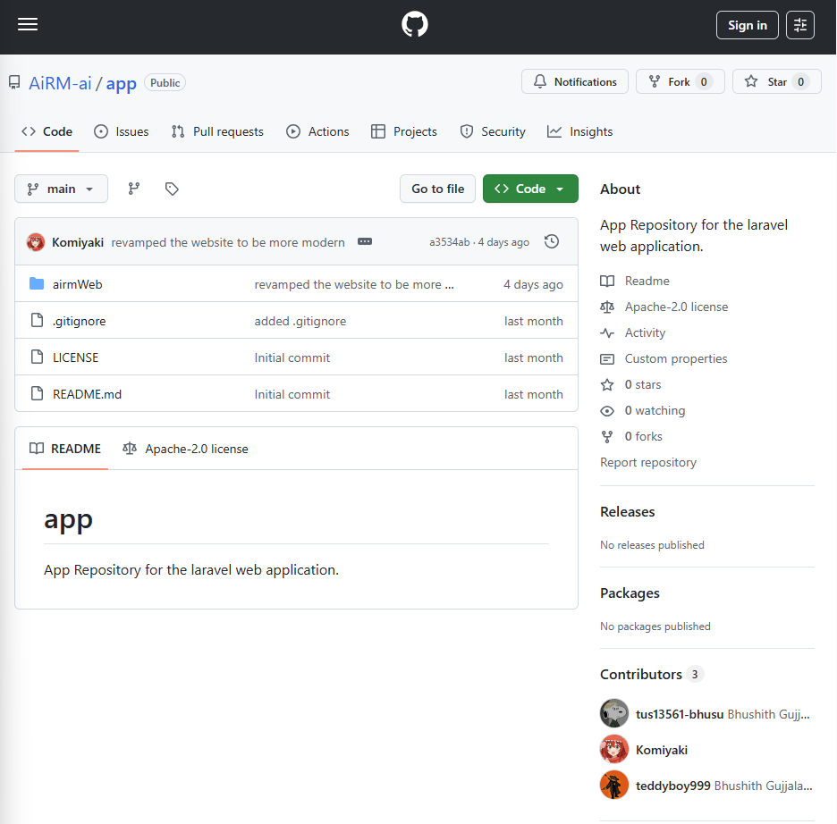
- Install github and set up account:
  - If using Windows 11: https://www.youtube.com/watch?v=AdzKzlp66sQ
  - If using MacOS: https://www.youtube.com/watch?v=p0Js7IF17yI
- In the web browser in the search link, click on the green code button. It should look like this:
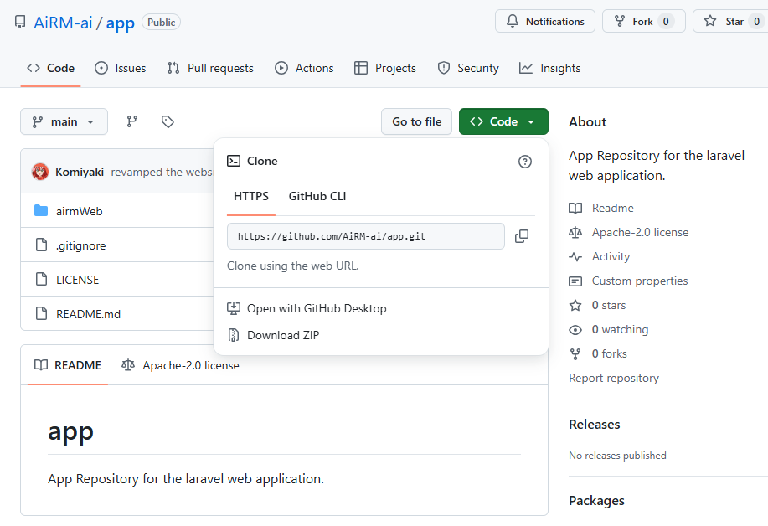
- Click on the copy button for the git repository for HTTP
- Now open your terminal or command prompt
- Clone the repository by executing the git clone command followed by the URL:
git clone https://github.com/AiRM-ai/app.git

If you need further help with instructions on cloning, please visit this site:
https://docs.github.com/en/repositories/creating-and-managing-repositories/cloning-a-repository
If cloned correctly, should look like this:
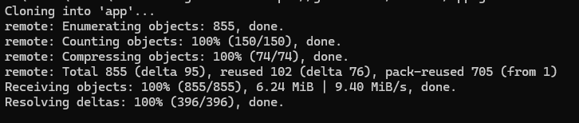
- Immediately after you have cloned the repository, type the command cd app into command prompt or terminal, in order to access the application.
  - If the application was saved into a specific directory, please get the file path first
  - If you don't want to use command prompt or terminal, you can manually find the application by looking at the file path that it was stored under.
    - For example, the application was saved into the following path , so navigate to that path and the application should be within the Documents file (in my example)
- After opening the “app” file, there should be three files: 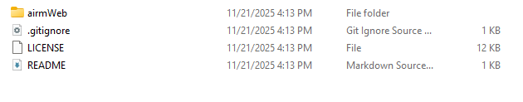
- Download mySQL (Server and Workbench), and create an account. Tutorial for doing so: (Link works for both MacOS and Windows): How To Install MySQL (Server and Workbench)
- After successfully installing mySQL, create the .env file and link it to mySQL: EP 20: Connecting Laravel to MySQL Using .env File | Learn Laravel the EASY Way

- Within command prompt or terminal, open airmWeb by using the command cd airmWeb
  - Use the command composer install and npm install in order to install a required dependencies
  - Once the dependencies have been installed, it should look like this:
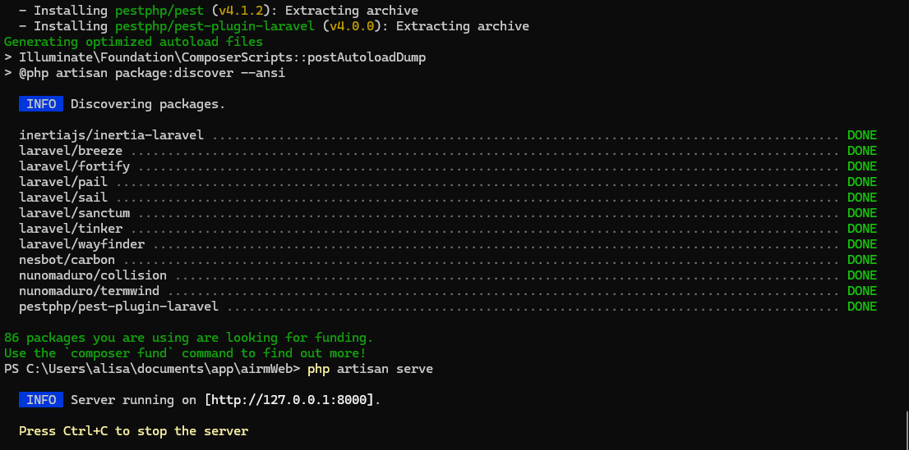
- Now open two terminals, on one terminal run the command php artisan serve, and within the other command, run npm run dev (make sure you are in the path with the application as shown above). Click + CTRL the link for php artisan serve in order to start the server (run the application).
- In order to run the model, open another terminal. Make sure that you are within the app file path. To run the model, install the dependencies by typing this command into the terminal:
pip install xgboost scikit-learn pandas numpy as well as
pip install fastapi pandas numpy
- Once the dependencies are installed type the command uvicorn main:app --reload --host 127.0.0.1 --port 8010 in terminal, and the terminal should look like this:
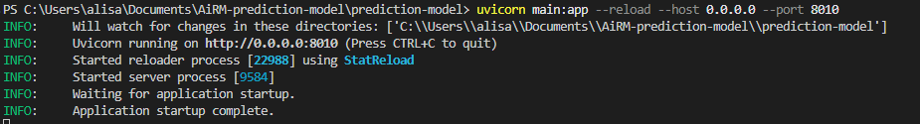

- To open the server, click + on the link provided within php artisan serve terminal output
- Now that your server is running and you have opened the AiRM website in your browser, you will be greeted by the “Home” page.
  - This page introduces AiRM with a clean, modern layout and provides an overview of what the system does.
- To access the About page, move your mouse to the top-right corner of the screen and click the “About” button in the navigation bar.
  - This page explains the mission of AiRM, the purpose of the company, and the values the system was built upon.
- Next, you can learn more about AiRM’s features by clicking “Product” from the same top navigation bar.
  - The Product page explains the main functionalities of AiRM, such as inventory prediction, regional analytics, and AI-powered pricing optimization.
- To understand the core technology behind AiRM, click the “Technology” button.
  - On this page, you can read about the AI models, data processing pipeline, backend structure, and the tools used to build the system.
- If you want to see the people behind AiRM, click the “Team” button on the navigation bar.
  - This page introduces the developers who worked on the project and their roles within the team.
- To reach out or learn how to communicate with the team, click the “Contact” button.
  - This page typically includes contact information where users can write to the email provided questions or feedback.
- In the top-right corner of the navigation bar, you will find a button labeled “App.”
  - Clicking this button will take you to the AiRM Web Application Login Page, where you can access the actual system features.
    - If you are a new user, you must click the “Register” link on the login page. Fill out the required information to create your AiRM account.
      - Fill out your name, email and password. Then click the register button at the bottom.
      - Please read more on how to register in the “Registering an Account on the AiRM platform” section
    - If you already have an account, enter your login credentials into the login form and click the “Login” button.
      - Input your email and password then click login to go to the AiRM web app.
      - Additionally, you can click “Remember me” so that you do not need to fill out the information the next time you wish to login.
      - If you have forgotten your password, you may click the “forgot your password?” button, where you can input your email so that an email can be sent to you to input a new password of your choosing. (Follow the instructions in the email to reset password)
  - Once logged in, you will be taken to the web application dashboard, where you can upload documents, view predictions, access your item catalog, and use all AiRM features.
    - Please read more on how to login in the Logging into AiRM section

User Account Creation and Login:

Registering an Account on the AiRM Platform:
When you first access the App page, you’ll either be asked to login. If you don’t have an user account already registered, please follow these instructions to register an account.

Please select “register instead” on the login page:
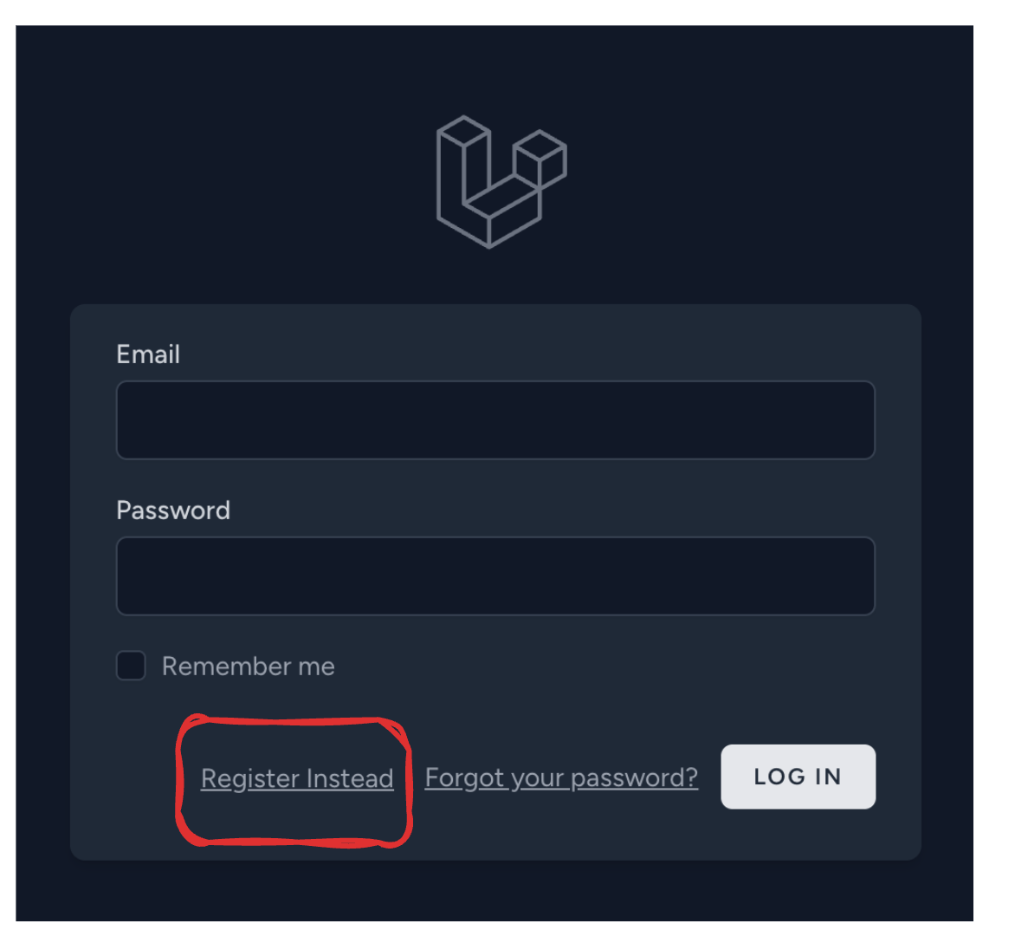
Please enter all the required details and information in the registration portal:
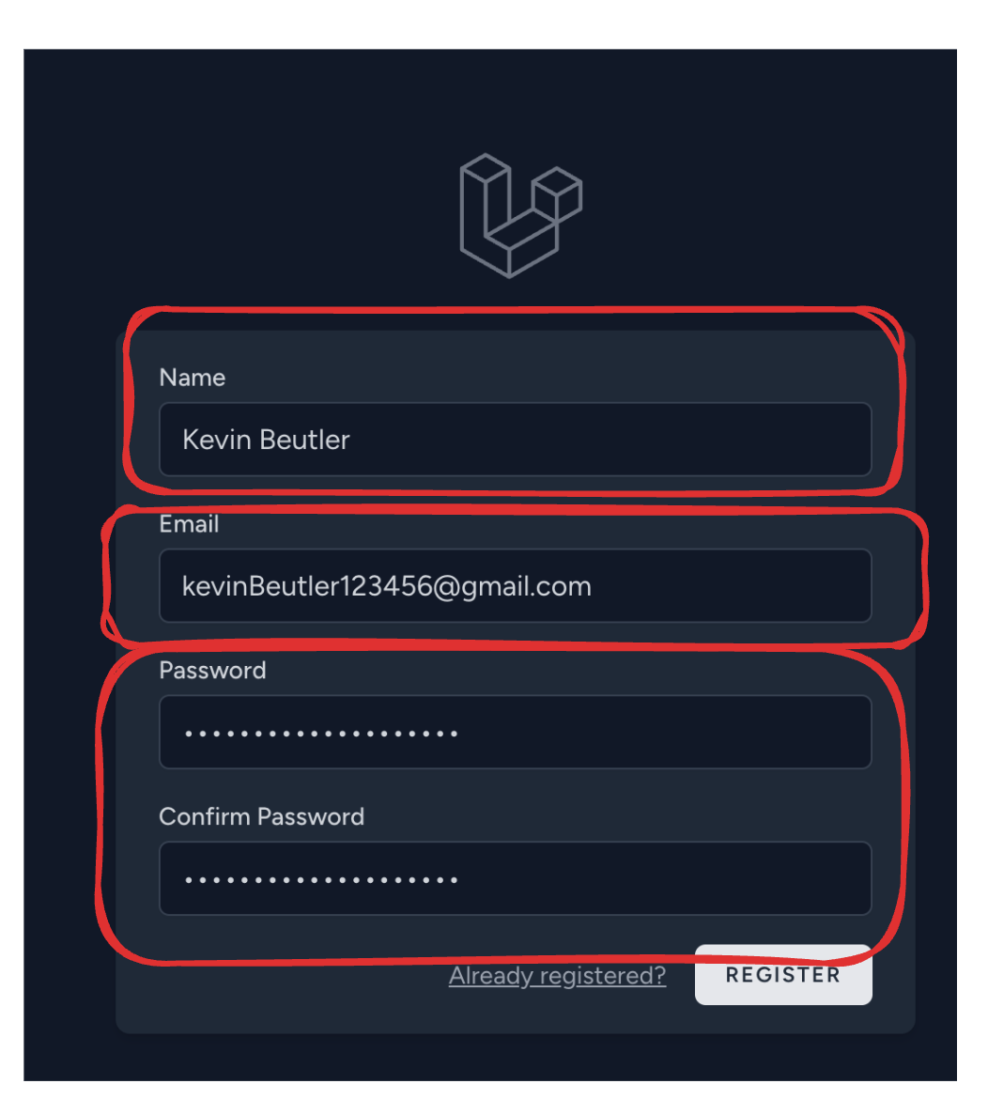
Make sure:
- Your name is your full name, it will be used as your account username.
- Please enter a valid email address, you might need it later in the future when resetting your password or logging back in when you forgot your account’s password.
  - Remember, your email must be in lowercase letters.
- Please enter a password that is more than 8 characters long, has at least one number, and has at least one special character in it.
- Make sure to remember your name, email, and password, they will be used when you login to the AiRM platform again.
After you have verified the above information, please click the register button,

You should be able to visit this screen:
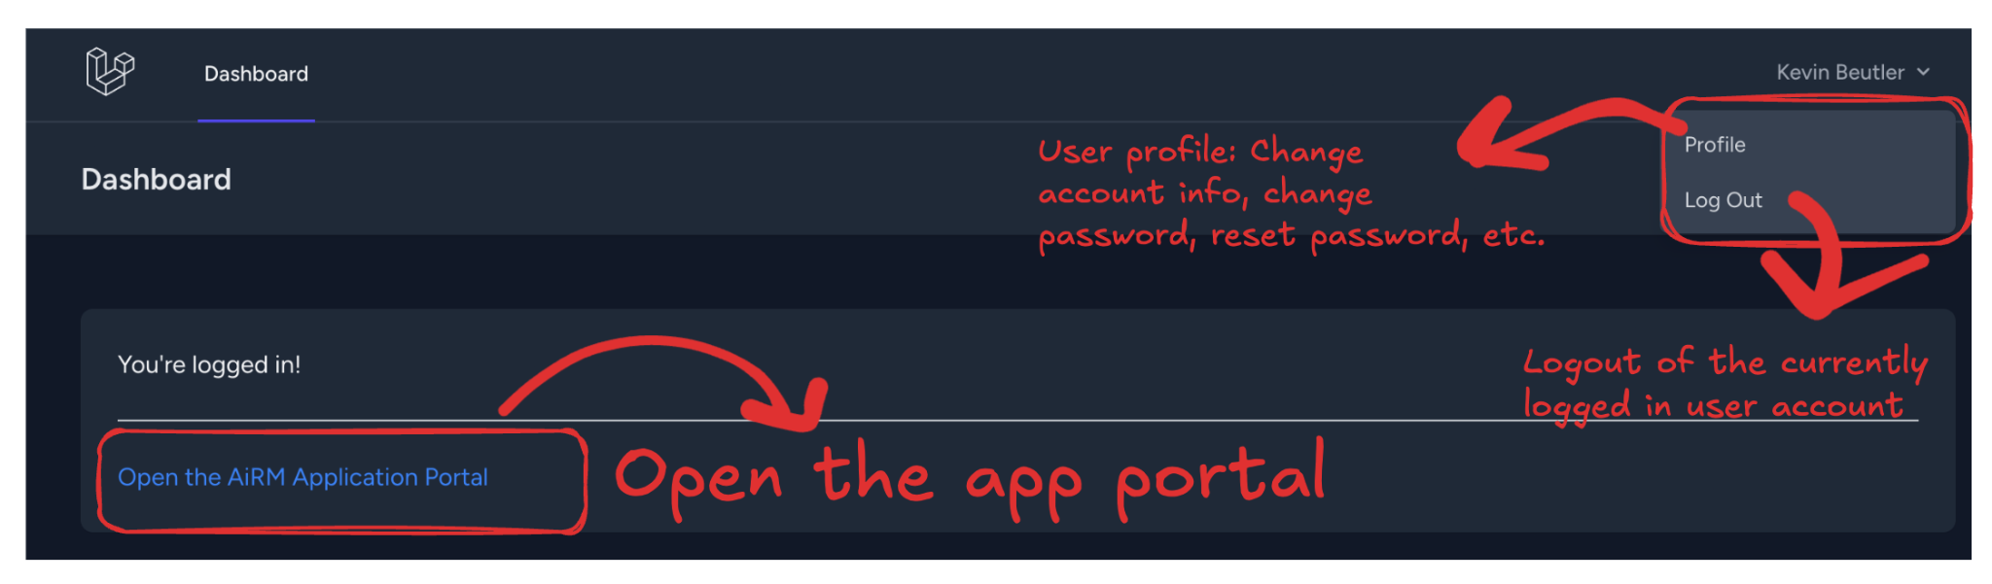
You can access the AiRM portal by clicking “Open the AiRM Application Portal”.
You should now be able to use the software!

Logging into a registered account on the AiRM Platform:
Clicking on the “App” link in the top navbar will lead you right to the login page. Now, from here, follow these steps to log back into the user account you created earlier:

Please enter all the necessary account information: Email Address, and the correct password. Then, click the “Log In” button!
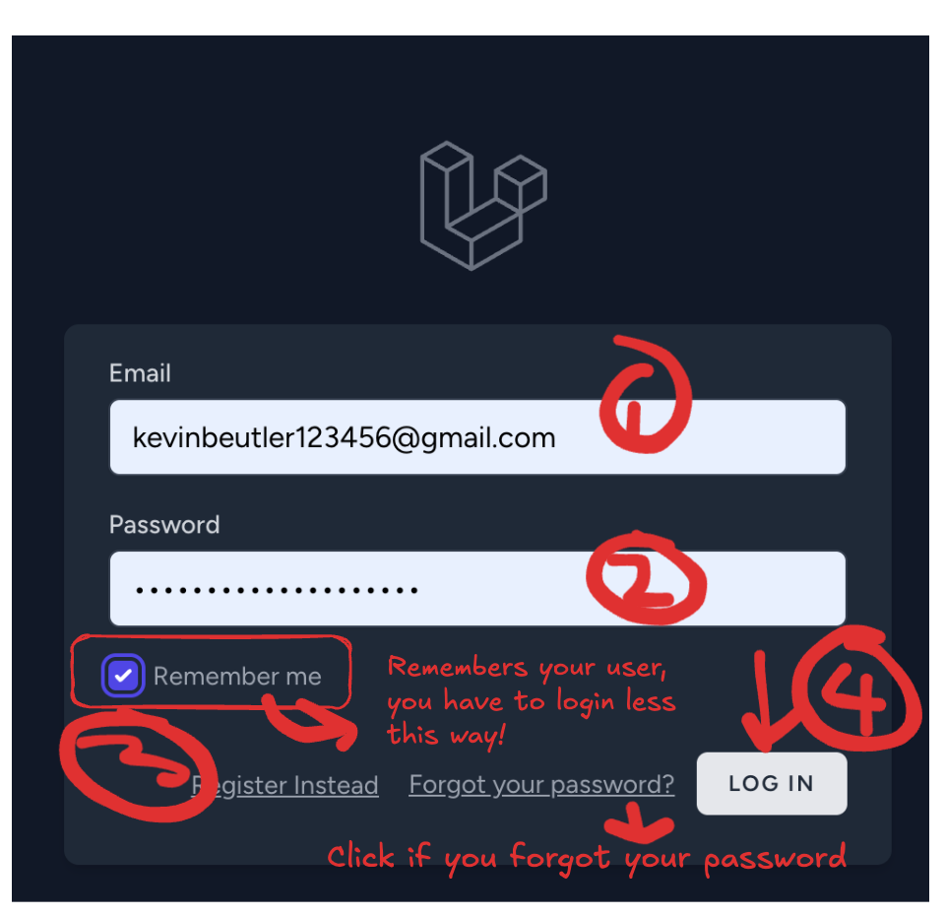
This should lead you right to the application portal of AiRM. Please read the next section to understand how to use the application platform.

Using the AiRM Software:
Continuing from after registering into a new account or logging into the system as an already registered user on the platform. Follow these steps to make the most of the software:

After logging into an existing user account, or upon first registration, you should see an application page like this:
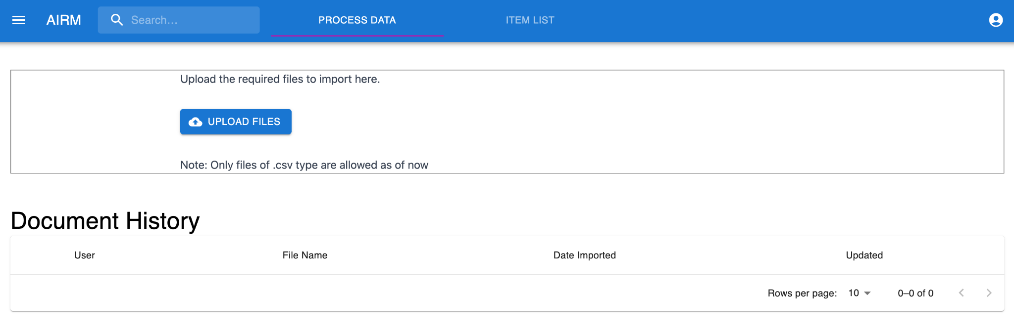
To get started, please upload a CSV FILE only. Please follow these instructions on what format to follow:
- CSV files only! Read here on what a CSV file is:
  - https://en.wikipedia.org/wiki/Comma-separated_values
- Please make sure the data in your CSV file follows this format:
  - https://data.austintexas.gov/Transportation-and-Mobility/Arterial-Management-Materials-Warehouse-Inventory/hcaw-evi2/about_data
  - Otherwise the system may fail to give you an accurate result.
Once you have a file that suits all the above requirements, please upload it like this:
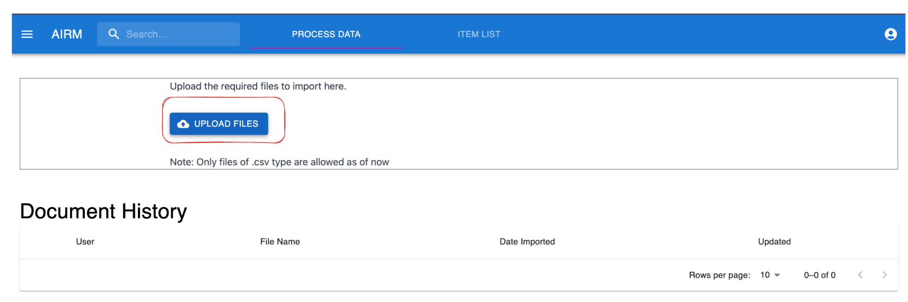

You should get a success message as the following:
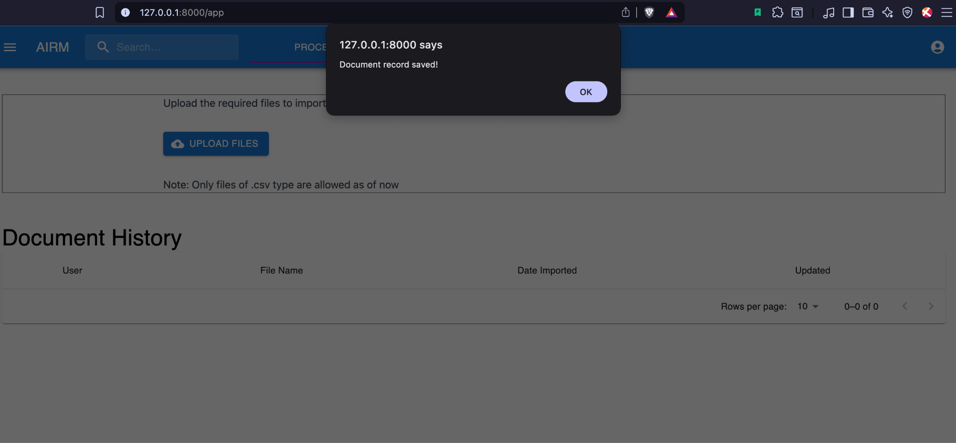
Now, you should see the updated document result as such:
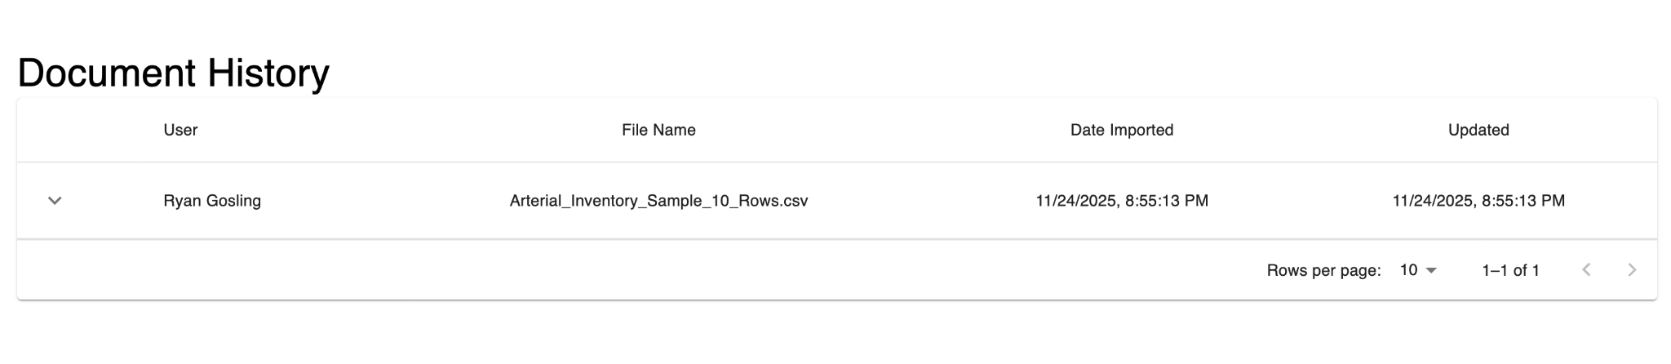
Please click the drop down arrow on the left to reveal a detailed view.
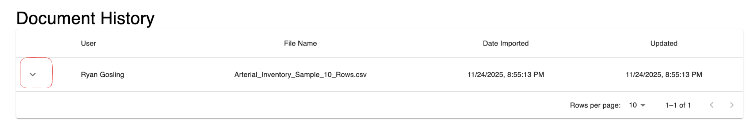

You should see the document content as so.
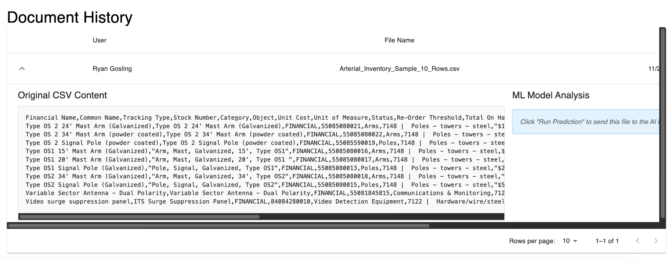
Scroll to the right, and click the “Run Analysis” button to get your predicted dates!
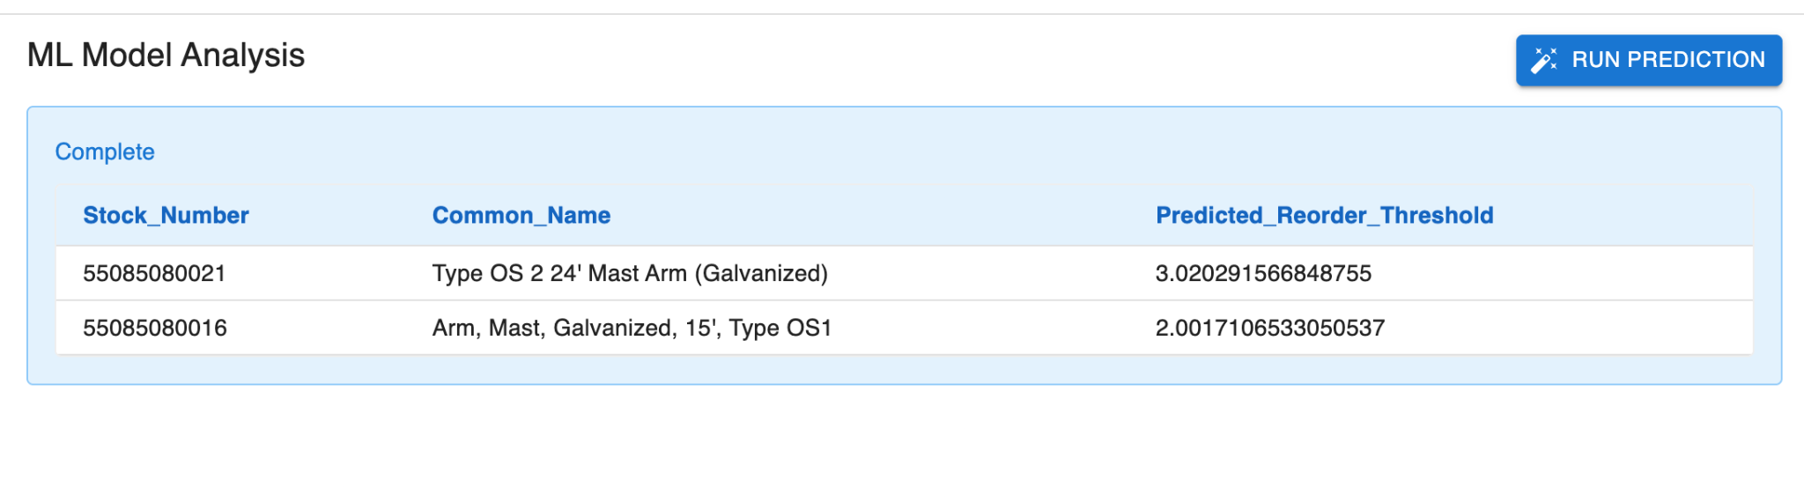
You have successfully used the base functionality of the AiRM software!

